Module 1
1 System of linear equations with examples.

Ex1
import numpy as np

A = np.array([[1, 1],
[1, -1]])

b = np.array([0, 0])

solution = np.linalg.solve(A, b)

print("Solution:")
print(solution)

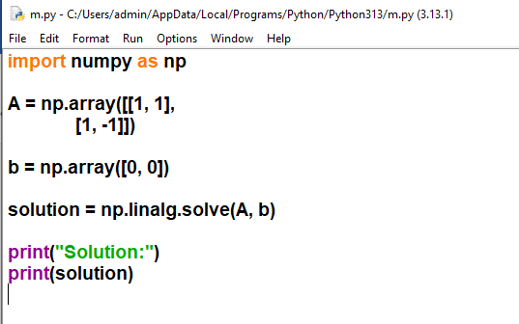

EX2
import numpy as np

A = np.array([[1, 1, 1],
[2, 1, -1],
[1, -1, 1]])

b = np.array([0, 0, 0])

solution = np.linalg.solve(A, b)

print("Trivial solution:")
print(solution)
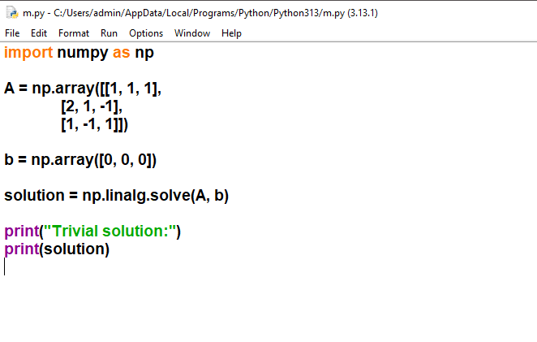

2.Matrix representation of a system of linear equations.

Matrix Representation in Python (Using NumPy)
import numpy as np

# Coefficient matrix
A = np.array([[2, 3],
[1, -1]])

# Variable matrix (for representation)
X = np.array(['x', 'y'])

# Constant matrix
B = np.array([8, 2])

print("Coefficient Matrix A:")
print(A)

print("\nVariable Matrix X:")
print(X)

print("\nConstant Matrix B:")
print(B)

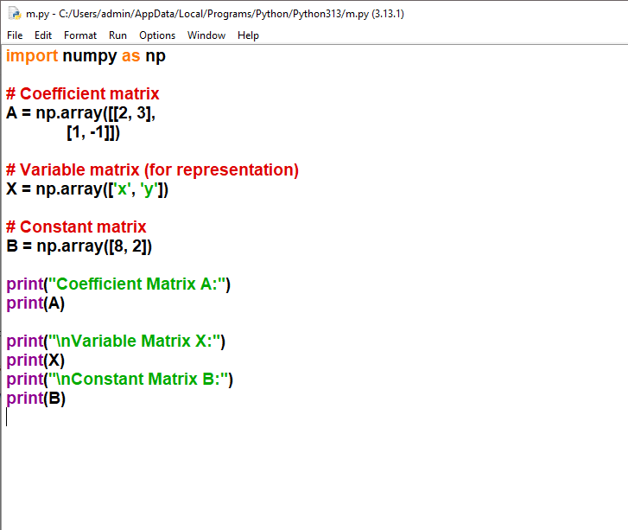

3.Matrix representation of a system of linear equations.
import numpy as np
# Example system of linear equations:
# 2x + 3y - z = 1
# 4x + y + 2z = 2
# 3x + 4y - 5z = 3
print("Example System of Linear Equations:")
print("2x + 3y - z = 1")
print("4x + y + 2z = 2")
print("3x + 4y - 5z = 3\n")
# Matrix representation: AX = B
# A = coefficient matrix, X = variable vector, B = constant vector
A = np.array([[2, 3, -1],
[4, 1, 2],
[3, 4, -5]], dtype=float)

X = np.array([['x'], ['y'], ['z']]) # Variable symbols
B = np.array([1, 2, 3], dtype=float)
print("Matrix Representation (AX = B):")
print("A (Coefficient Matrix):")
print(A)
print("\nX (Variable Vector):")
print(X)
print("\nB (Constant Vector):")
print(B)
print("\nAugmented Matrix [A|B]:")
print(np.c_[A, B])

# Solve the system
solution = np.linalg.solve(A, B)
print(f"\nSolution: x = {solution[0]:.2f}, y = {solution[1]:.2f}, z = {solution[2]:.2f}")

